December 20, 2024

**Sources of Data**

Tax Defaulted Property Auctions in Tulsa OK

tax-defaulted property auctions in Tulsa, OK through several sources:

1. **Tulsa County Treasurer's Office**: They hold an annual real estate auction for properties with unpaid taxes or special assessments. You can find auction information and a list of properties on their website1. Here's the link to their June Real Estate Auction page.
2. **Tax Liens and Foreclosure Homes Websites**: Websites like TaxLiens.com provide listings of tax-delinquent properties available for auction in Tulsa County. These sites often include details about the properties, estimated rental values, and auction dates.
3. **Local Real Estate Agents**: Consulting with local real estate agents who specialize in tax-defaulted properties can also be helpful. They can provide insights, guidance, and access to resources that might not be publicly available.
4. **County Properties for Sale Listings**: The Tulsa County Treasurer's Office also maintains a list of properties that were not sold at auction and are now owned by the county. These properties may be auctioned again, and you can find more information on their County Properties for Sale page.

Data Sources_Property Auction Plan

Tulsa OK

[County Properties - Treasurer](https://www2.tulsacounty.org/treasurer/properties-for-sale/county-properties/)

As of December 20, 2024, there was only this listed in the properties for Sale List

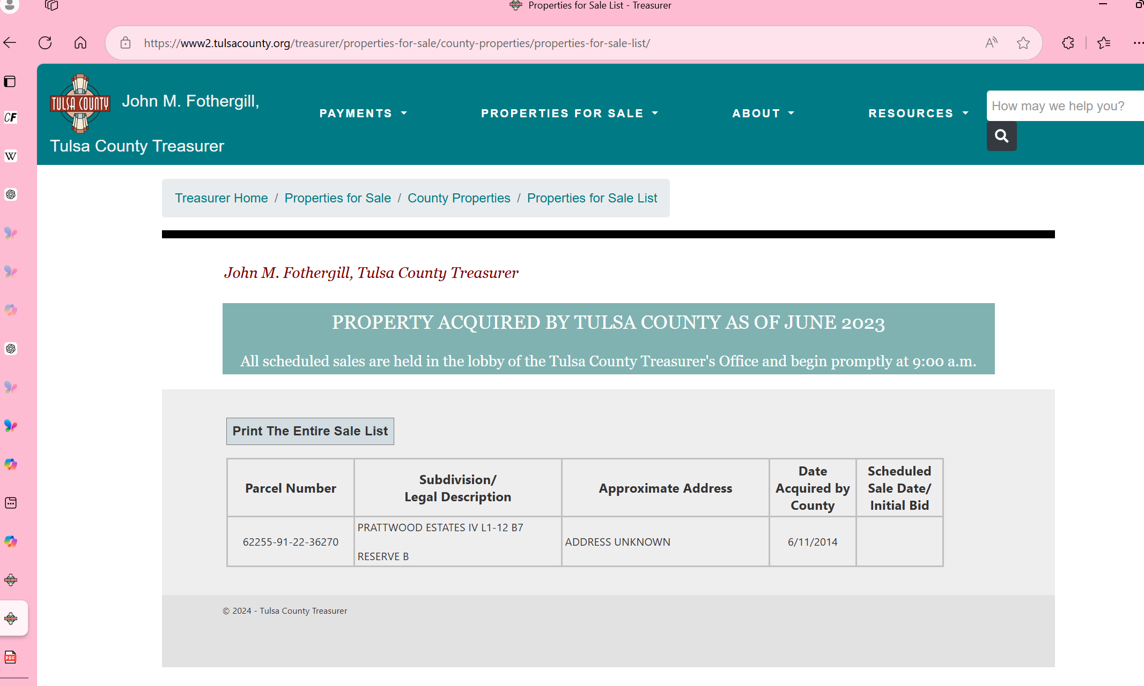

**How bid range will be calculated**

1. **Research Past Auctions**: Look at the winning bids for similar properties in previous auctions. This will give you a baseline for what properties in similar locations and conditions have sold for.
2. **Property Assessment**: Check the property's assessed value and compare it to similar properties in the area. This can help you gauge a reasonable starting bid.
3. **Market Value**: Determine the market value of the property by looking at recent sales of comparable properties in the neighborhood. Websites like Zillow or Redfin can be helpful for this.
4. **Set a Maximum Bid**: Decide on the maximum amount you are willing to pay based on your budget, potential repair costs, and the property's potential value after improvements.
5. **Consider Additional Costs**: Factor in any additional costs such as property taxes, maintenance, and potential legal fees for clearing the title.
6. **Create a Bid Range**: Based on your research, set a range for your bids. For example, if similar properties have sold for $50,000 to $70,000, you might set your range from $40,000 to $60,000, depending on your assessment of the property's condition and potential.